H.T No
Regulations:
A22

Sreenidhi Institute of Science and Technology
(An Autonomous Institution)
Code No:9CC02 Date: 03-September-2024 (FN)

B.Tech II-Year I- Semester External Examination, September -2024 (Supplementary)
SIGNALS AND SYSTEMS (ECE and ECM)

Time: 3 Hours Max.Marks:60

Note: a) No additional answer sheets will be provided.
b) All sub-parts of a question must be answered at one place only, otherwise it will not be valued.
c) Missing data can be assumed suitably.
Bloom's Cognitive Levels of Learning (BCLL)

Remember | L1 | Apply | L3 | Evaluate | L5
Understand | L2 | Analyze | L4 | Create | L6

Part - A Max.Marks: 6x2=12

Answer all QUESTIONS, EACH QUESTION CARRIES 2 MARKS.

 |  | BCLL | CO(s) | Marks
1 | How do you approximate a signal using orthogonal functions? | L1 | CO1 | [2M]
2 | Write the Convolution property of Fourier Transform. | L3 | CO2 | [2M]
3 | Give the relationship between bandwidth and rise time of a signal. | L4 | CO3 | [2M]
4 | State the Properties of Convolution Integral | L5 | CO4 | [2M]
5 | Illustrate the term Aliasing? | L2 | CO5 | [2M]
6 | Conclude ROC of Z transform. | L6 | CO6 | [2M]

Part – B Max.Marks: 6x8=48
ANSWER ALL QUESTIONS. EACH QUESTION CARRIES 8 MARKS.

 |  | BCLL | CO(s) | Marks
7. | Derive the expression for component vector C₁₂ of approximating the function f₁(t) over f₂(t) and also prove that the component vector becomes zero if the f₁(t) and f₂(t) are orthogonal. | L1 | CO1 | [8M]
 | OR
8 | Discuss about power and energy of a signal and check whether is power or energy signal. Find its power/energy. | L2 | CO1 | [8M]
9. | Find the trigonometric Fourier Series for the exponential as depicted in figure over the interval 0 < t < . 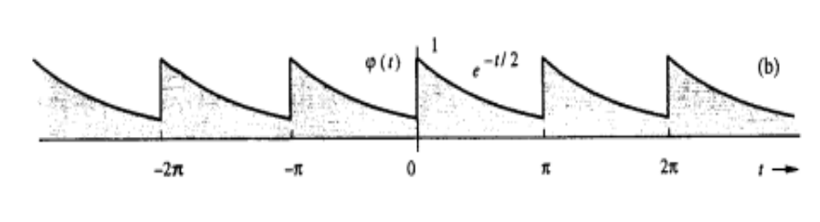 | L3 | CO2 | [8M]
 | OR
10 | 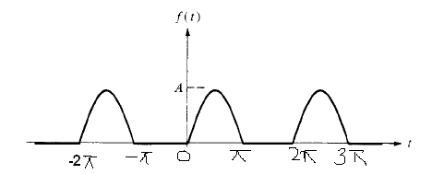  Find the Fourier series for the following signal. | L3 | CO2 | [8M]
11 | i. Explain about ideal filter Characteristics.  ii. Obtain the conditions for the distortion less transmission through a system both in time and frequency domain. | L4 | CO3 | [8M]
 | OR
12 | Determine whether the system governed by the equation y(n)= 5x(n)+1 is linear, Time Variant, Causal, and Stable or not. Assume that x(n) represents the input to the system and y(n) represents its output. | L3 | CO3 | [8M]
13 | Consider an LTI system with system function, 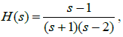  Obtain the system response and ROC in S-Plane. | L5 | CO4 | [8M]
 | OR
14 | Find the Laplace transform of | L4 | CO4 | [8M]
15 | Determine the Nyquist rate for the given continuous time signal:  x(t) = 6 cos50πt+20 sin 300πt+10 cos 100πt. | L6 | CO5 | [8M]
 | OR
16 | Derive and explain the Sampling Theorem with required diagrams | L3 | CO5 | [8M]
17 | Consider a system with system function  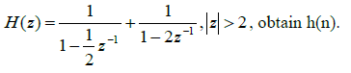 | L5 | CO6 | [8M]
 | OR
18 | Evaluate the value of the signal corresponding to the following Z-transform:  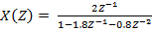 | L6 | CO6 | [8M]

-- 00 -- 00 –

